1. **UT_IT_TEST_1_Scrum Master Successful Login:**

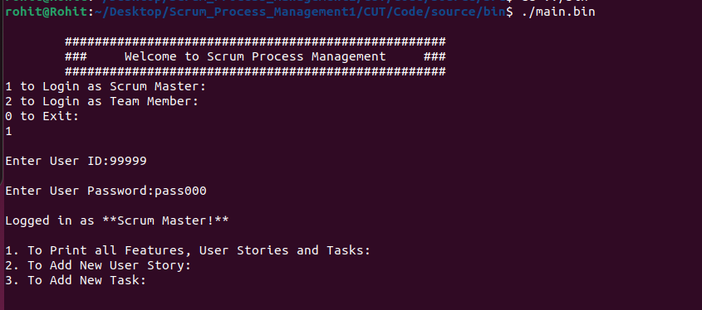

1. **UT_IT_TEST_2_Scrum Master Unsuccessful Login:**

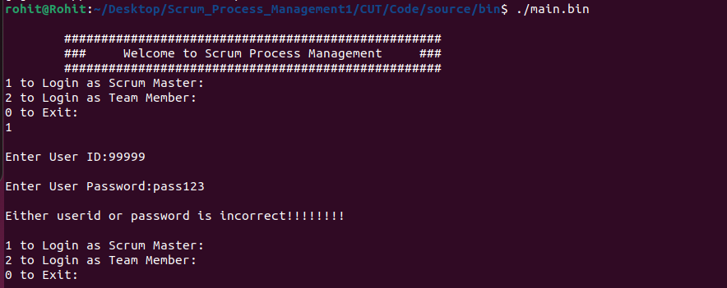

1. **IT_TEST_3_ Print Features Stories and Tasks:**

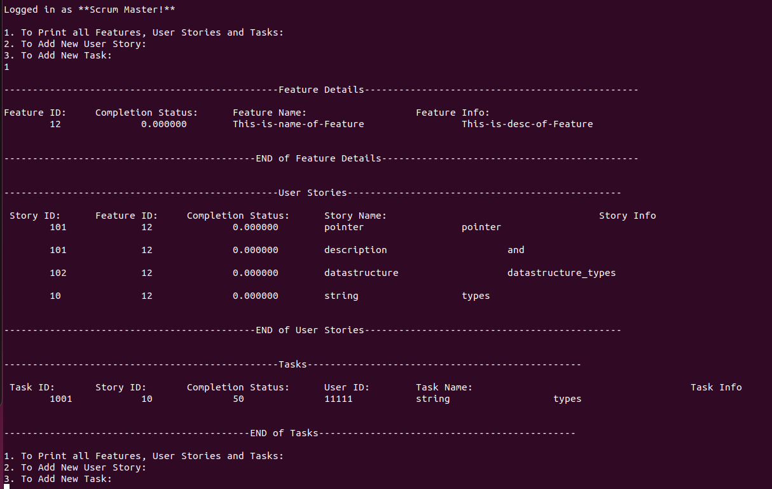

1. **UT_IT_TEST_4_Display Users Tasks:**

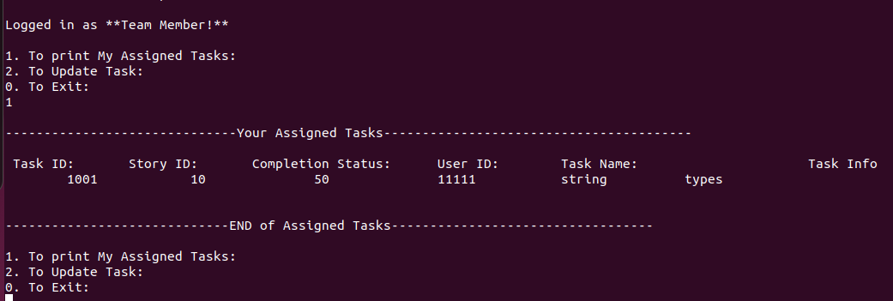

1. **UT_IT_TEST_5_CreationofTaskLL and Updating of tasks.csv file:**

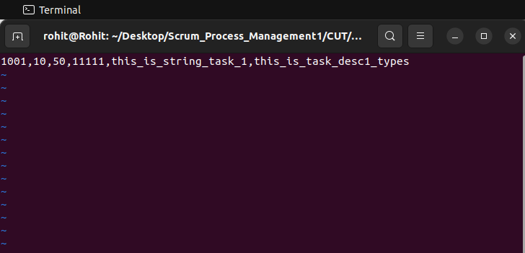

1. **UT_IT_TEST_6_Update Completion Status:**

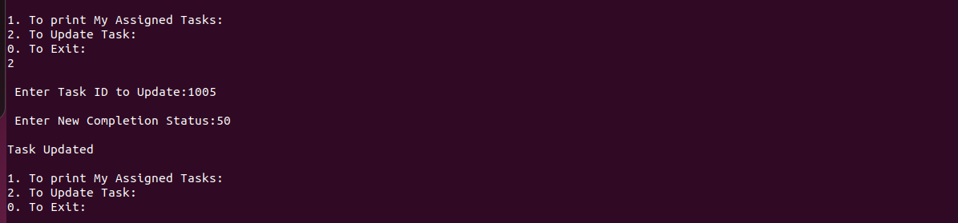

1. **UT_IT_TEST_7_Print Updated Task:**

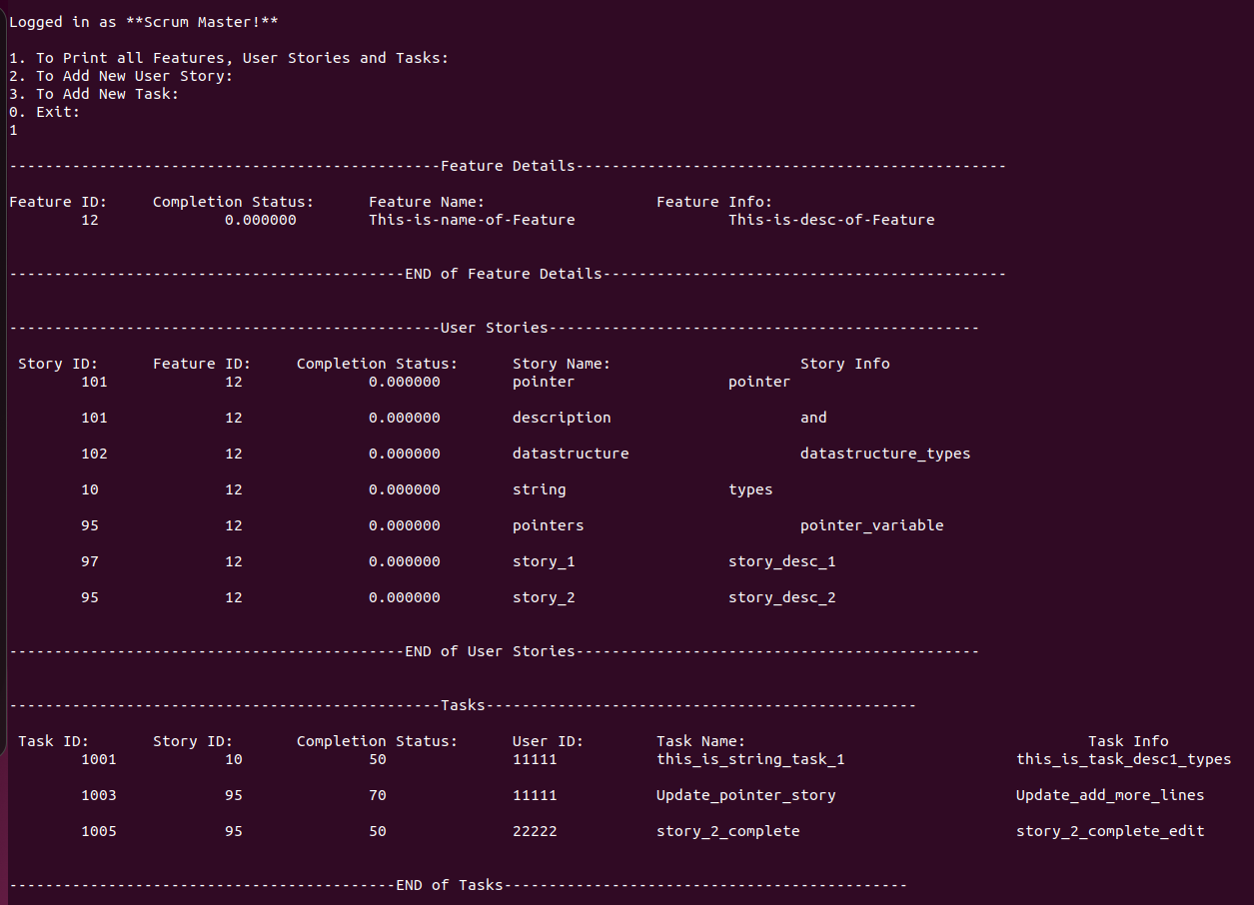

1. **UT_IT_TEST_8_Print Assign Task of Team Member**

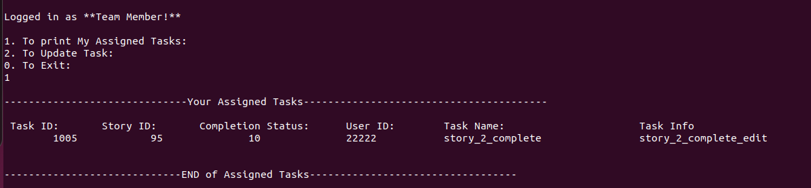

1. **UT_IT_TEST_9_Scrum Master Add New Tasks:**

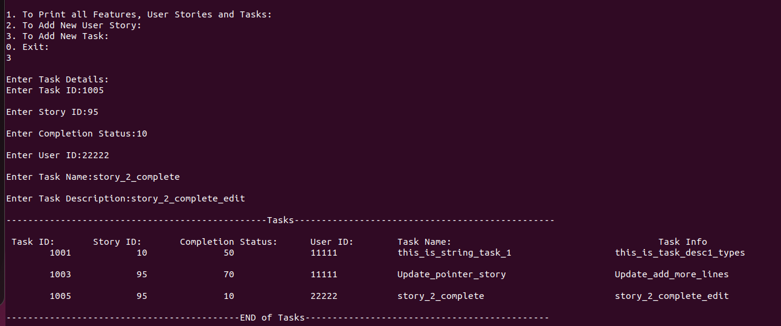

1. **UT_IT_TEST_10_Scrum Master Add New Story:**

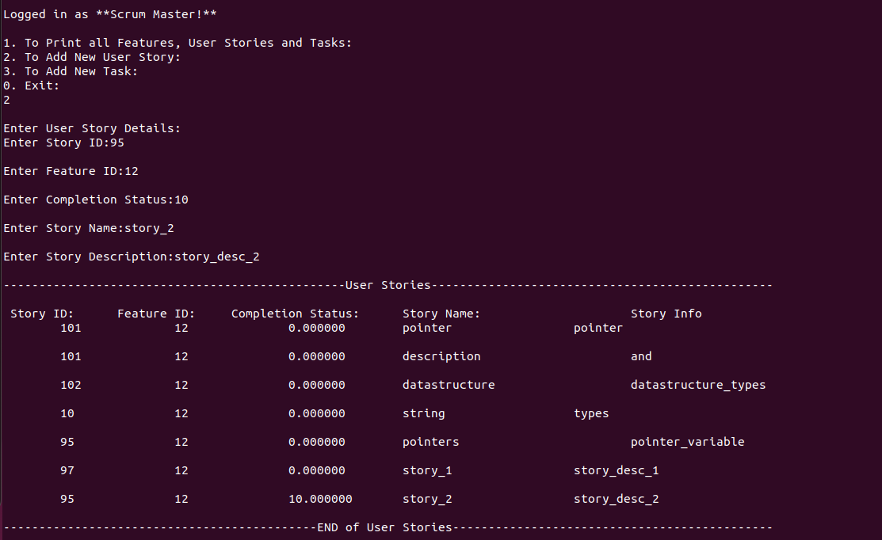

1. **UT_IT_TEST_11_Exit from Main Menu:**

